**How to measure irradiance using the pyranometer system?**

**Step 1:**

Load the following code on to the Arduino board (here, used is the Arduino mega board). Open serial monitor on the Arduino and the two values of irradiance will be shown.

***NOTE:***

In the command terminal of the Raspberry Pi 4, do proper installation to get the data from the Serial Monitor of the Arduino IDE in the python code.

***ARDUINO CODE:***

#include <Wire.h>

#include <Adafruit_ADS1015.h>

Adafruit_ADS1115 ads(0x48);

float Direct_Voltage = 0.0;

float Direct_Irradiance = 0.0;

float Indirect_Voltage = 0.0;

float Indirect_Irradiance = 0.0;

void setup(void)

{

Serial.begin(9600); //baudrate = 9600

ads.setGain(GAIN_FOUR); // -- 4x gain -- +/- 1.024V(max value) -- 1 bit = 0.03125mV (ADS1115)

ads.begin();

}

void loop(void)

{

int16_t adc0; // we read from the ADC, we have a sixteen bit integer as a result

int16_t adc1;

adc0 = ads.readADC_SingleEnded(0); //Read ADC0 value

Direct_Voltage = (adc0 * 0.03125); //Convert ADC to Voltage (milli volts)

Direct_Irradiance = (1.6 * Direct_Voltage); //Convert Voltage (volts) to Irradiance

adc1 = ads.readADC_SingleEnded(1);

Indirect_Voltage = (adc1 * 0.03125);

Indirect_Irradiance = (1.6 * Indirect_Voltage);

//Serial.print("Direct ADC Value: ");

//Serial.println(adc0);

//Serial.print("\t");

//Serial.print("Direct Voltage Value (mV): ");

//Serial.println(Direct_Voltage);

//Serial.print("\t");

Serial.print("Direct Irradiance Value (W/m^2): ");

Serial.print(Direct_Irradiance);

Serial.print("\t");

//Serial.print("Indirect ADC Value: ");

//Serial.println(adc1);

//Serial.print("\t");

//Serial.print("Indirect Voltage Value (mV): ");

//Serial.println(Indirect_Voltage);

//Serial.print("\t");

Serial.print("Indirect Irradiance Value (W/m^2): ");

Serial.print(Indirect_Irradiance);

Serial.println();

delay(8000); //depends on the delay of the mission

}

**Step 2:**

Make the connections as seen in the diagram below, connecting the Arduino (mega board), pyranometer sensors and raspberry pi (raspberry pi 4) with a breadboard.

***CONNECTION DIAGRAM:***

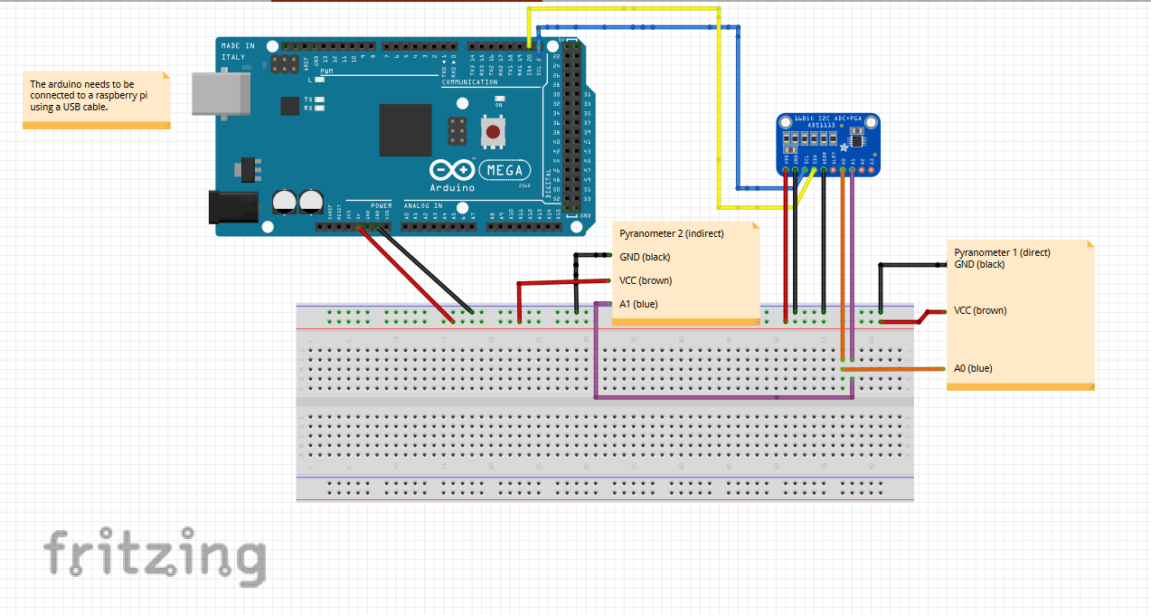

**Step 3:**

Run python script called “ReadingsToDB_ard.py” in the command terminal of the raspberry pi.

**Step 4:**

Open phpMyAdmin on the raspberry pi browser and login and see your table and database specified in the python script above getting updated. Click on “Refresh” under the “Browse” tab to see the table getting updated. The python script will continue running until explicitly stopped in the command terminal where it was started from.